March 2018 GATE Group-----Creating Pinball Machines
Hi All,
I found this idea on how to create “Paper Plate Marble Mazes”, and I started thinking about how my GATE students might be interested in creating something similar. That idea morphed into “Pinball Machines!”
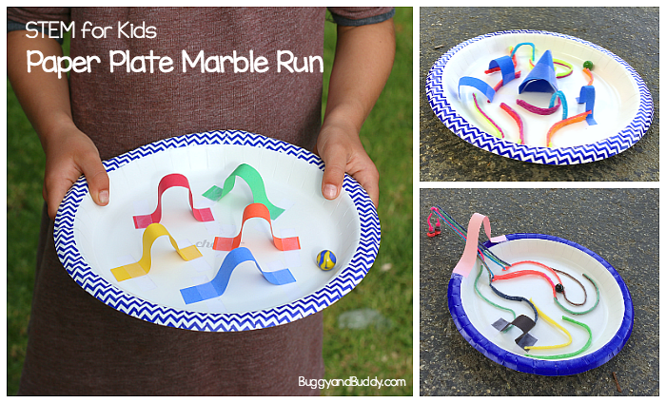
I showed the students some youtube videos of actual Pinball Machines, so they could see how they work and what mechanics are involved. https://www.youtube.com/watch?v=4VxDIrthyuM
Afterward, I shared materials: cardboard tubes, construction paper, pipe cleaners, scraps of paper, tape, etc…. and let them at it! All “machines” had to be built inside a paper box lid, so as to contain the marble that would be moving through the cool structures created.
I did find some other “cardboard” pinball machines on youtube as well, so once we were finished, the students were able to see some more creative designs. Here is the link that you might like to enjoy as well: cardboard creation https://www.youtube.com/watch?v=C4ZUrli2aOA

I really wanted our students to use their creativity and constructive thinking and collaborating to see what they could do in the hour that we had together today! It was great fun seeing them work out problems, make changes to ideas that failed, and get back at it!!

